
IGNOU GUESS PAPERS

MASTER DEGREE PROGRAMME
(2 year)
MEG-9
SPECIAL FEATURES OF IGNOU GUESS PAPERS
- By IGNOU Academic Counselor
- Top Rated 5 Guess Papers
- Fully Focused for Exams
- Best Guarantee of Success
- Strictly Based on Syllabus
and much more……………………..
GUESS PAPER — I
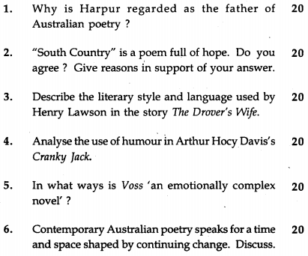
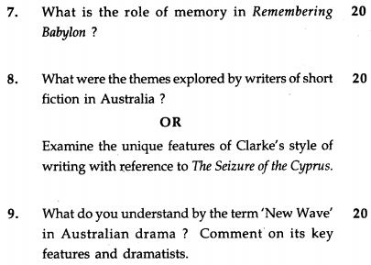
GUESS PAPER — II
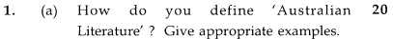
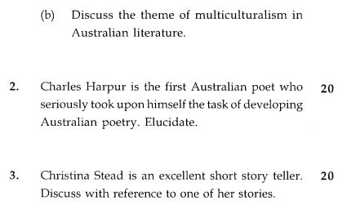

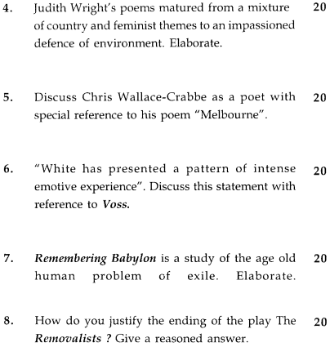
GUESS PAPER — III
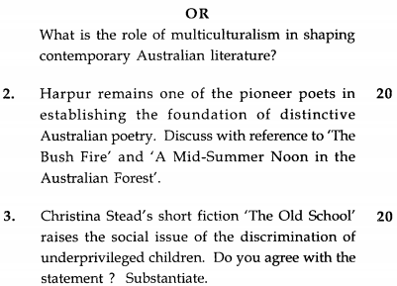
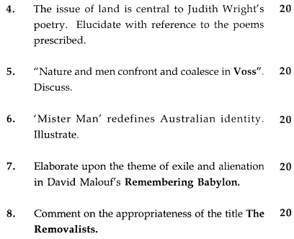
GUESS PAPER — IV
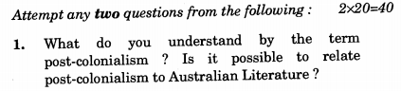
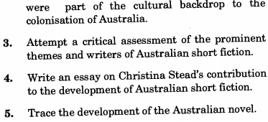
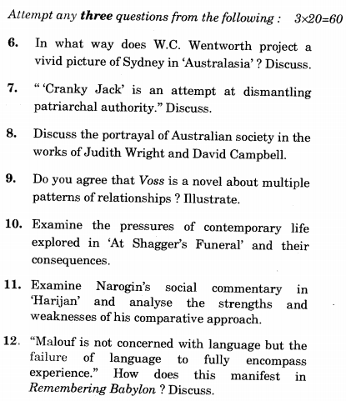
GUESS PAPER — V
